Name:- K. Lakshmi sravani

Reg no:-192111557

1. Generation of number series 1, 2, 3, 4,…..n

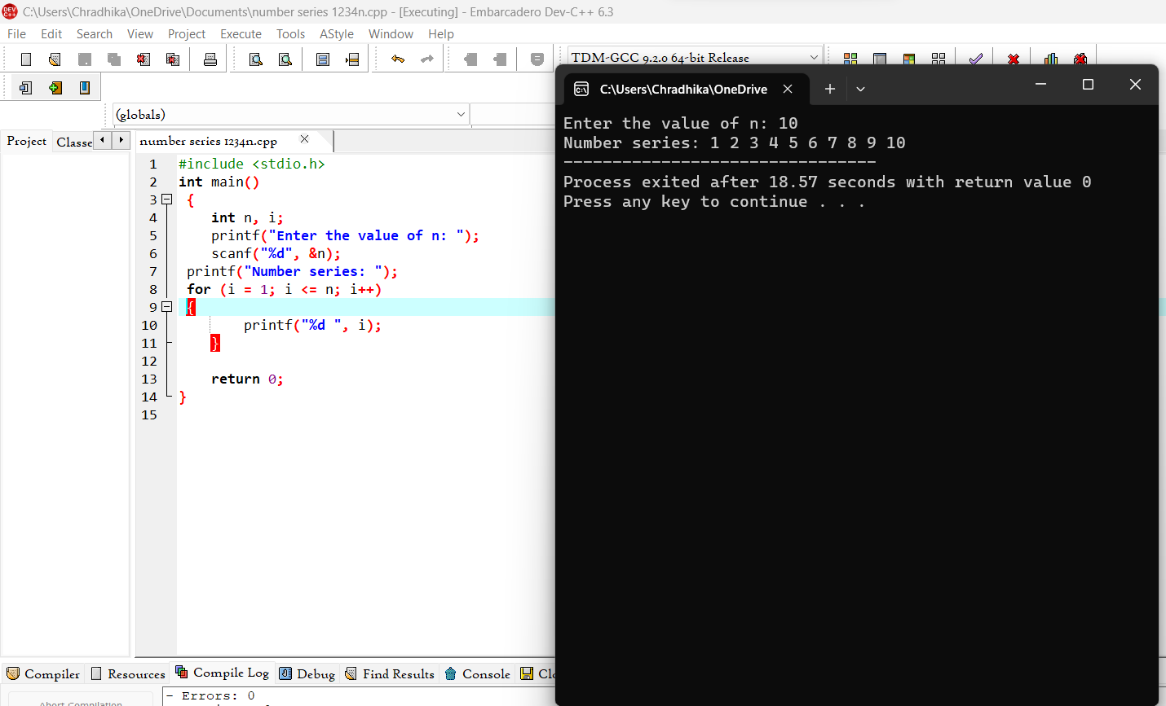

1. Generation of even number series 2, 4, 6, …..n

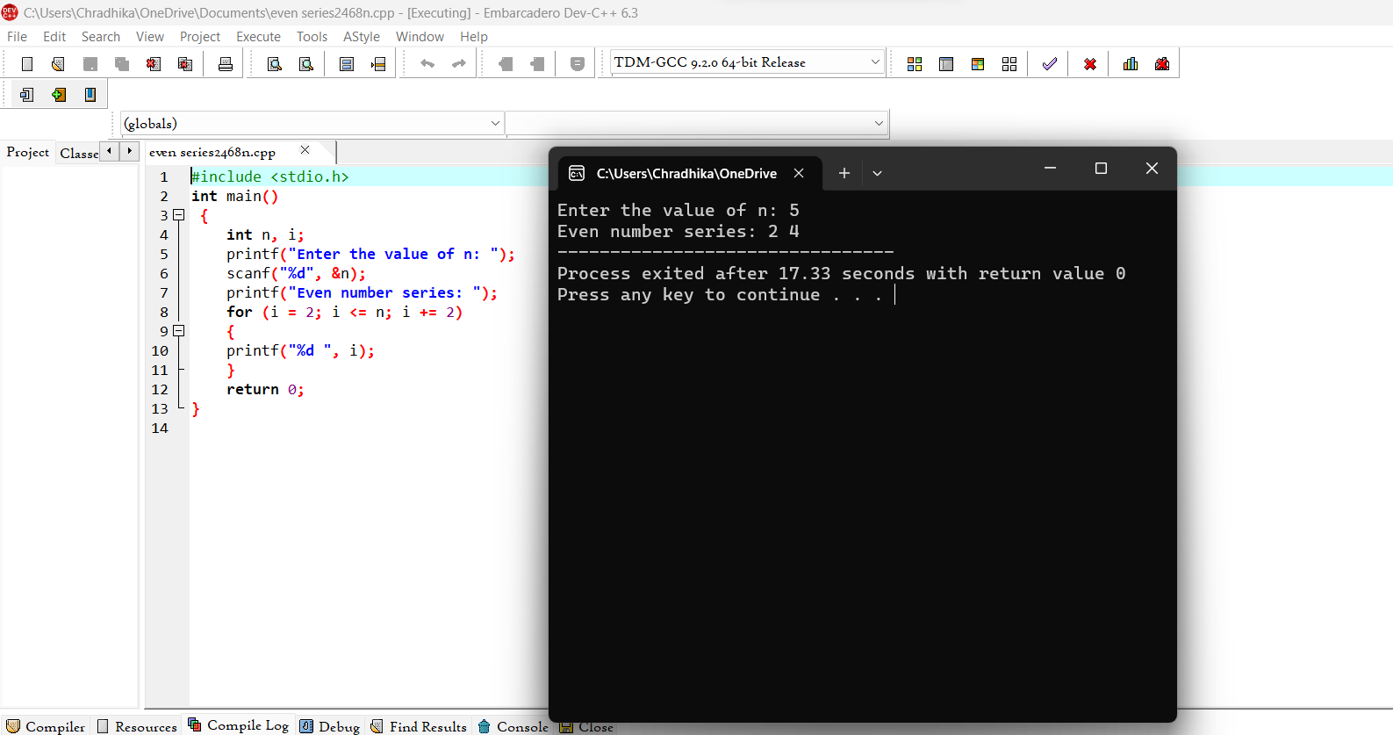

1. Generation of ODD number series 1, 3, 5, …..n

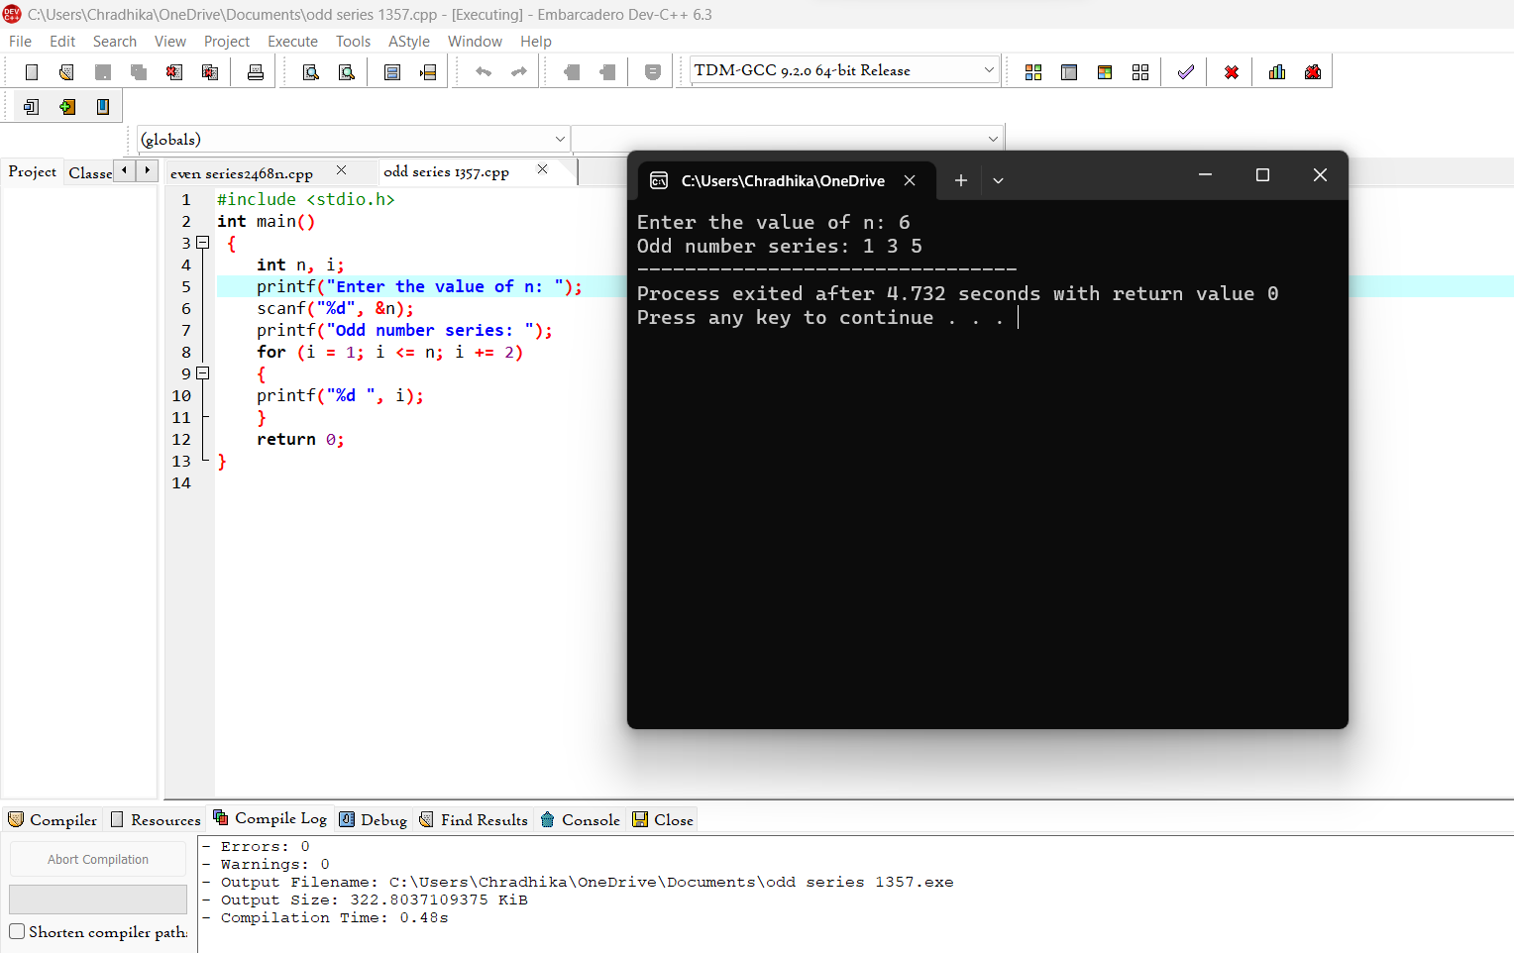

1. Generation of Fibonacci series 0, 1, 1, 2, 3, 5, 8, …..n

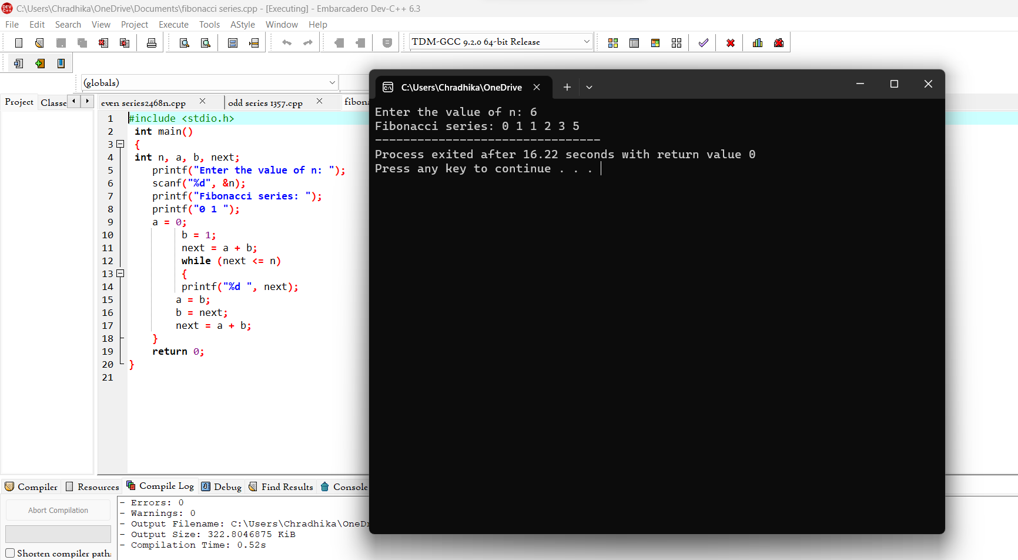

1. Summing up series 1 + 2 + 3 + 4….. +n

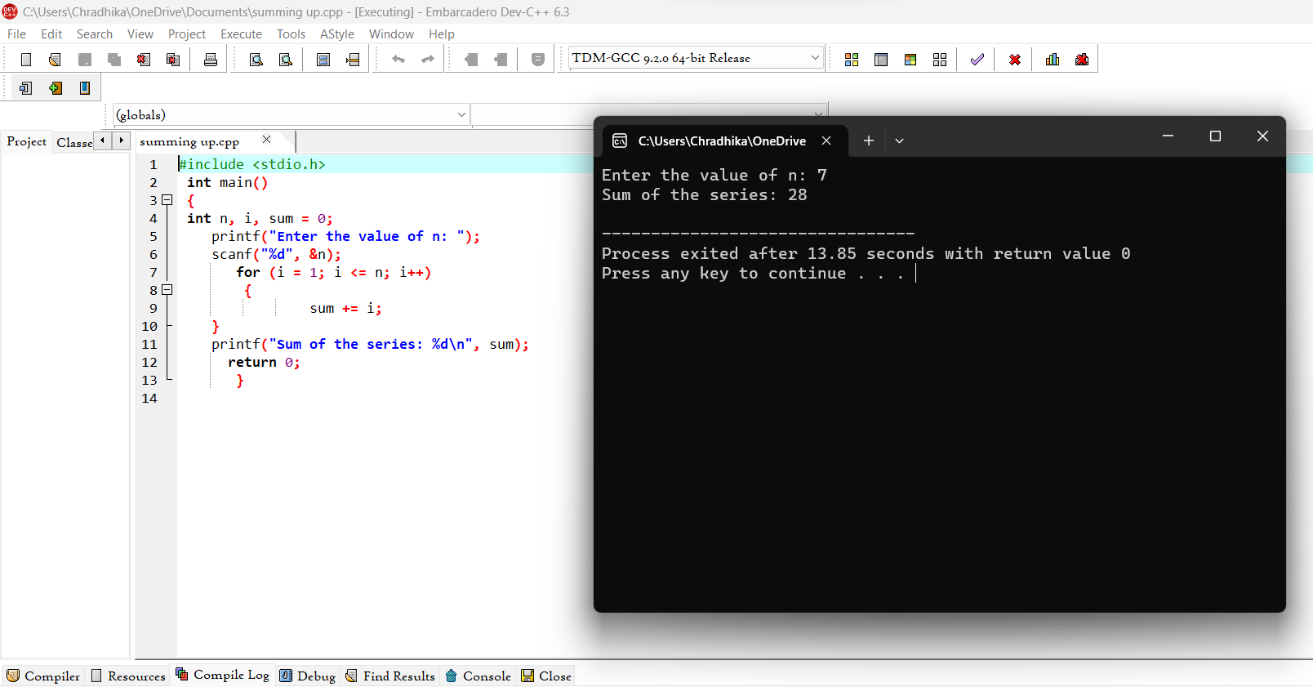

1. Summing up Even Number series

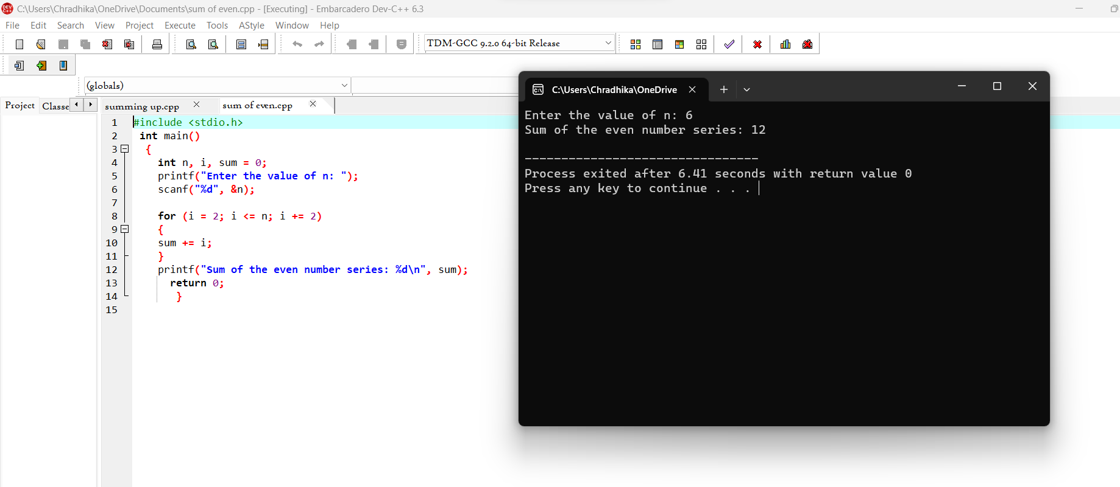

1. Summing up Odd Number series

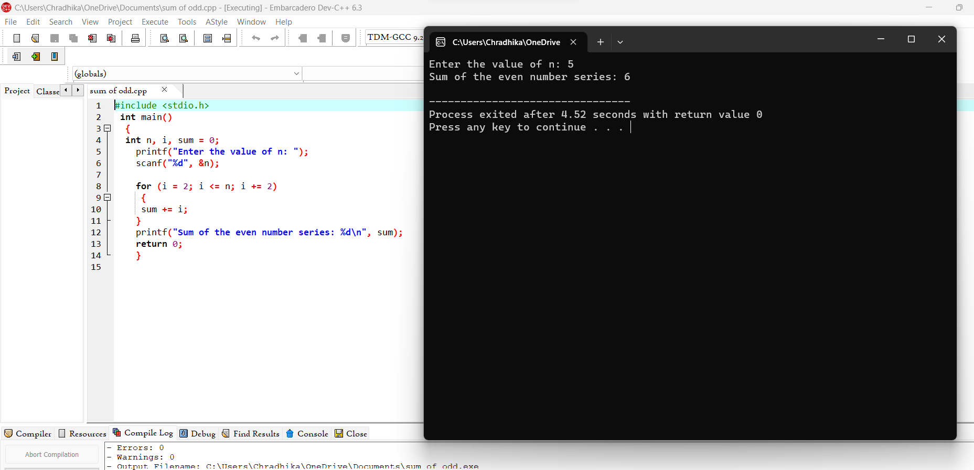

1. Summing up 1 – 2 + 3 – 4 + 5…. N

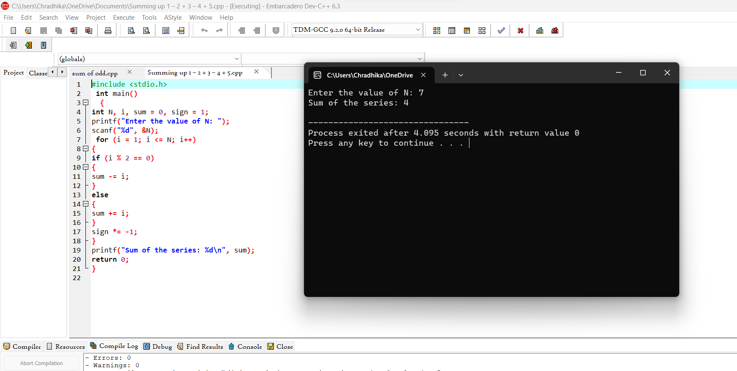

1. Summing up 12 + 22 + 32 + 42….. +n

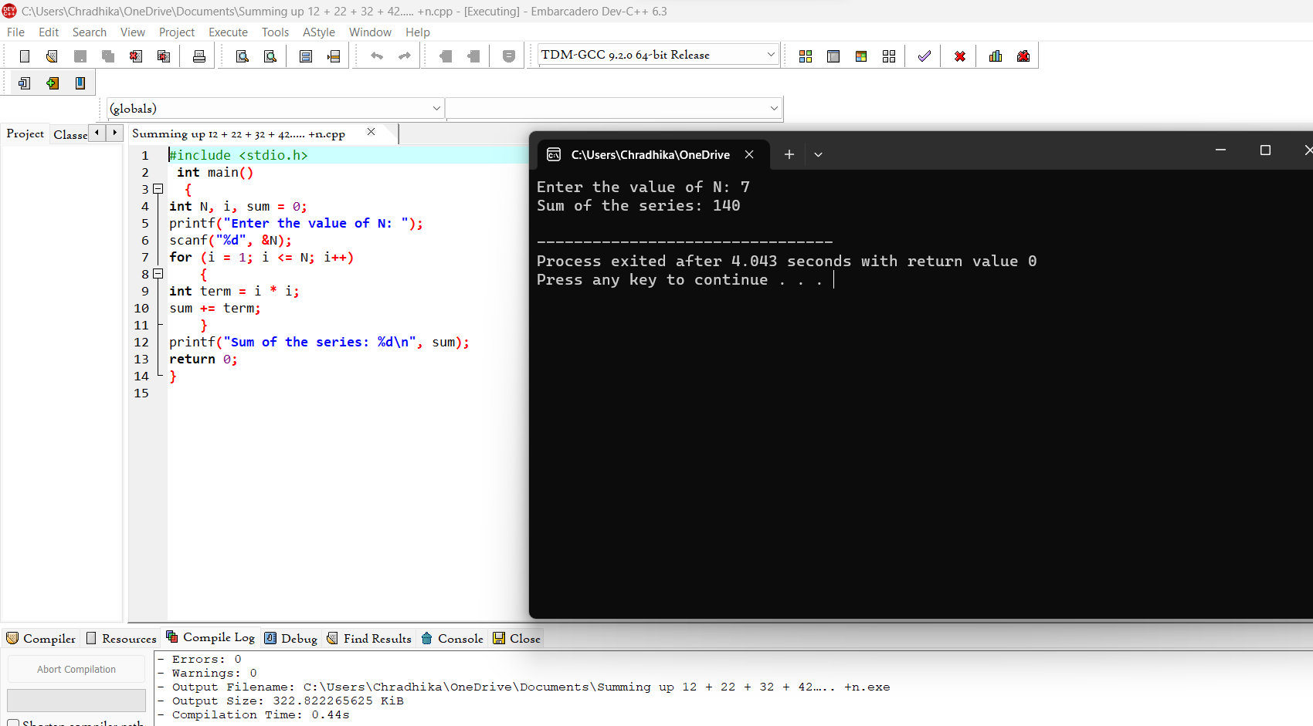

1. Summing up 22 + 42 + 62 + 82 + ….. n2

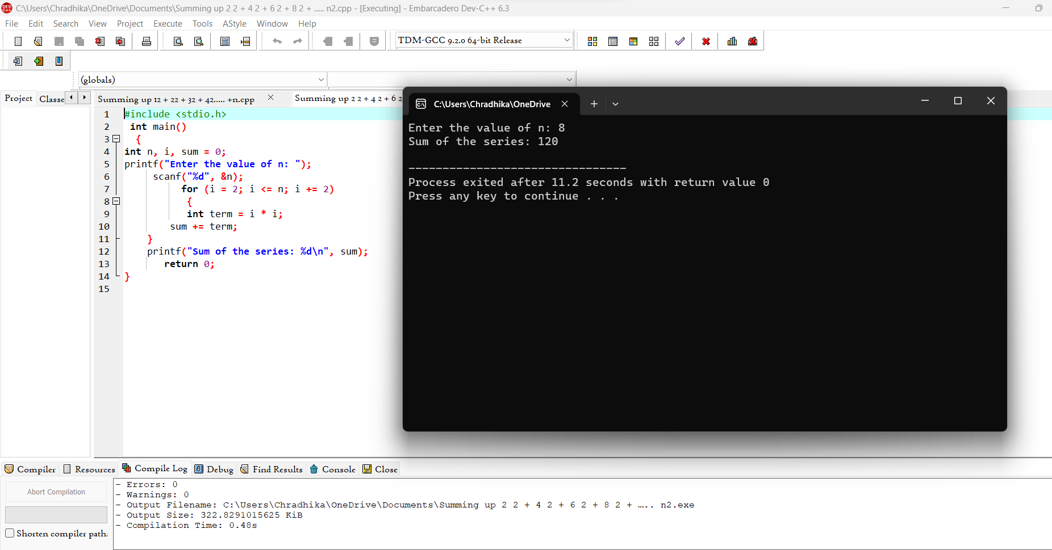

1. Summing up 11+22+33+44+ …. nn

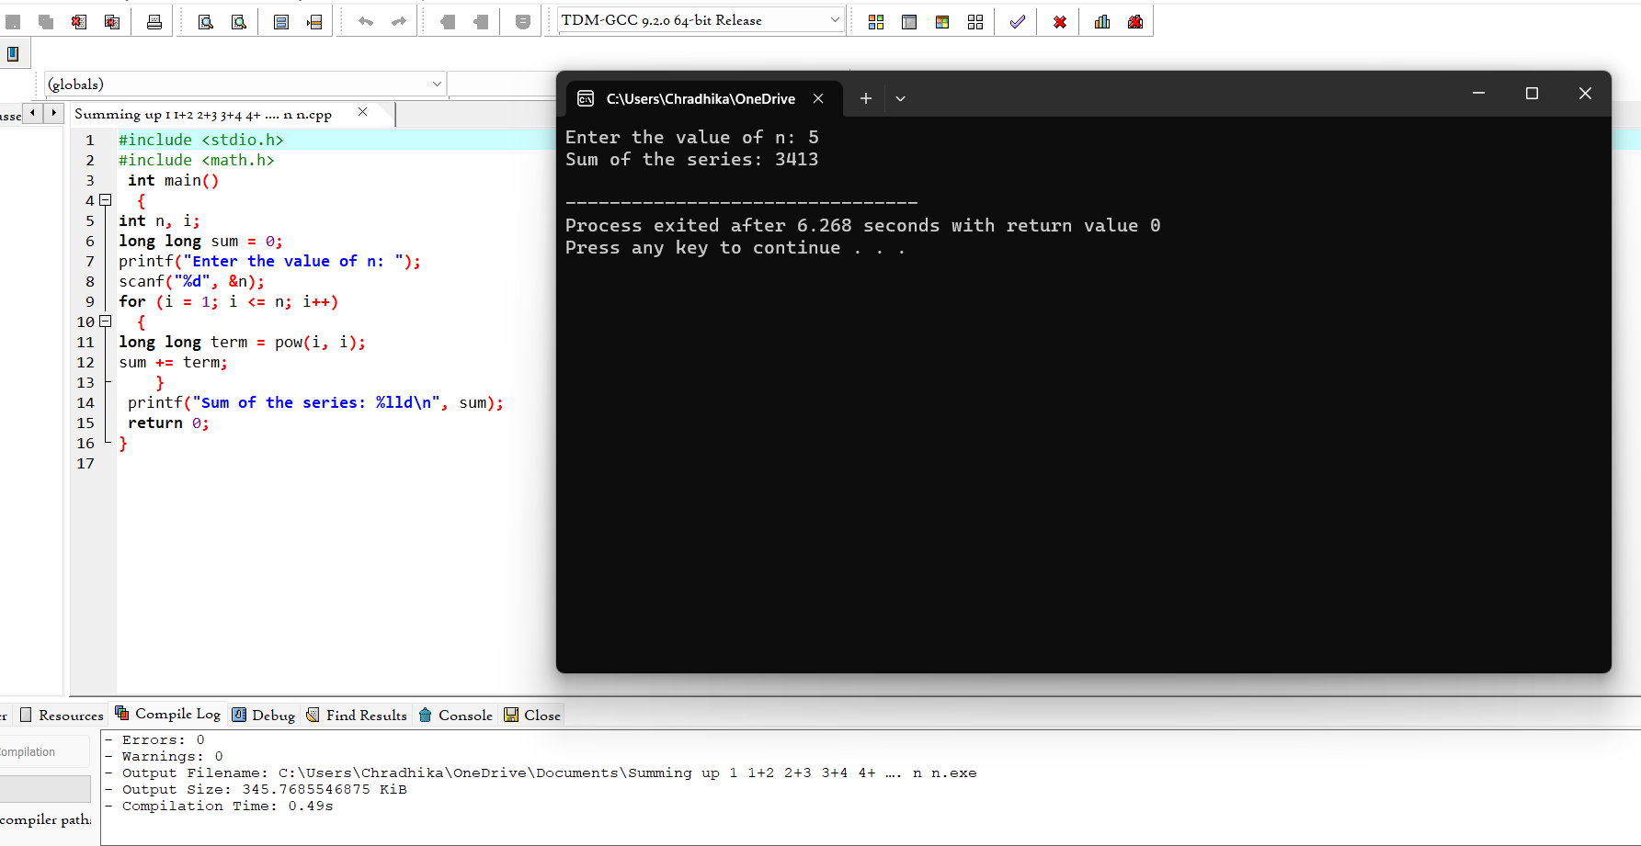

1. Summing up squares of Odd numbers

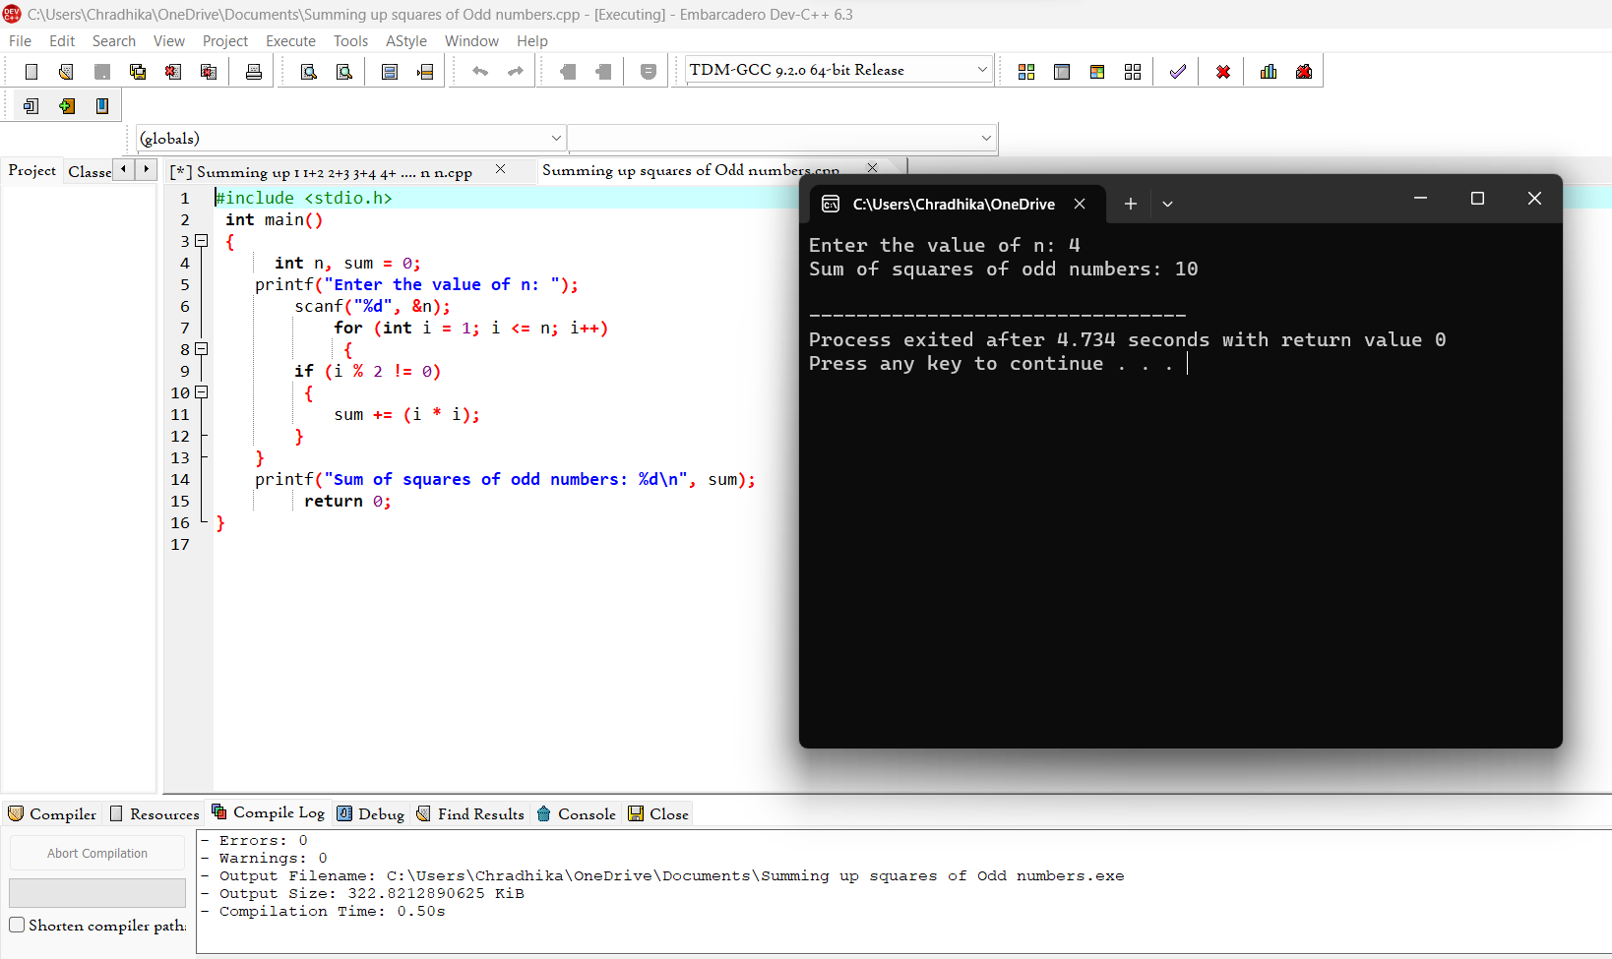

1. Summing up cubes of n numbers

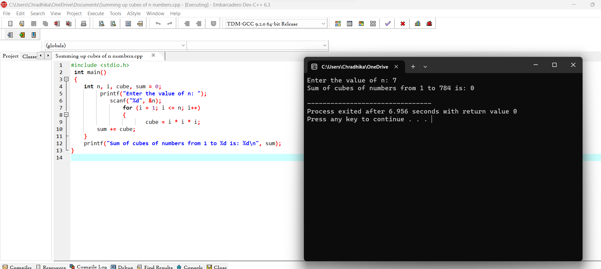

1. series (Factorial of a given number)

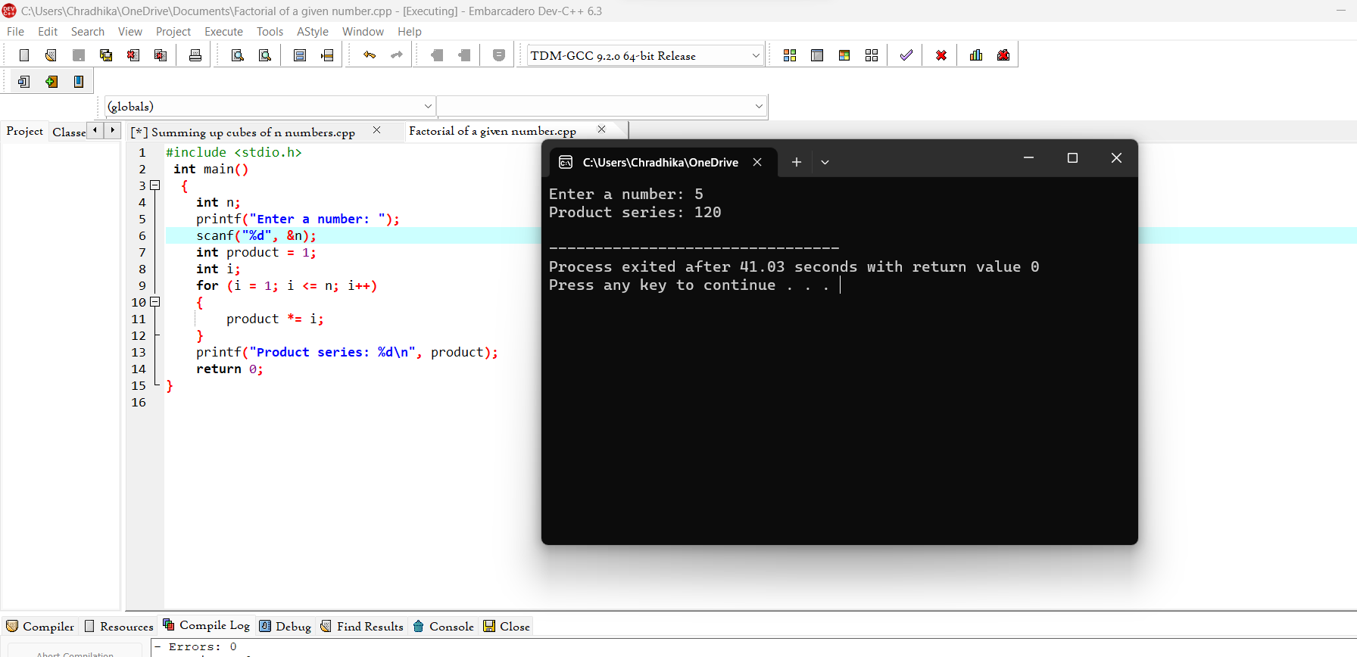

1. Finding given number is Armstrong or not

